Senegal

## Respect for rule of law (ROL) data

The data set shows the data on the respect of the rule of law for the country.

## # A tibble: 19 x 5  
## country iso3c date ruleOfLaw ruleOfLawCategory4   
## <chr> <chr> <dbl> <dbl> <chr>   
## 1 Senegal SEN 1996 -0.182 ROL moderately disrespected  
## 2 Senegal SEN 1998 0.0000340 ROL moderately respected   
## 3 Senegal SEN 2000 0.0334 ROL moderately respected   
## 4 Senegal SEN 2002 0.0656 ROL moderately respected   
## 5 Senegal SEN 2003 -0.0606 ROL moderately disrespected  
## 6 Senegal SEN 2004 0.00352 ROL moderately respected   
## 7 Senegal SEN 2005 0.0100 ROL moderately respected   
## 8 Senegal SEN 2006 -0.222 ROL moderately disrespected  
## 9 Senegal SEN 2007 -0.240 ROL moderately disrespected  
## 10 Senegal SEN 2008 -0.280 ROL moderately disrespected  
## 11 Senegal SEN 2009 -0.369 ROL moderately disrespected  
## 12 Senegal SEN 2010 -0.399 ROL moderately disrespected  
## 13 Senegal SEN 2011 -0.459 ROL moderately disrespected  
## 14 Senegal SEN 2012 -0.287 ROL moderately disrespected  
## 15 Senegal SEN 2013 -0.239 ROL moderately disrespected  
## 16 Senegal SEN 2014 -0.0818 ROL moderately disrespected  
## 17 Senegal SEN 2015 -0.142 ROL moderately disrespected  
## 18 Senegal SEN 2016 -0.106 ROL moderately disrespected  
## 19 Senegal SEN 2017 -0.149 ROL moderately disrespected

## Respect for rule of law (ROL) trend

The plot shows the trend of the respect for the rule of law for the country.

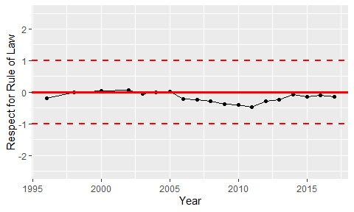

Trend of the Respect for the Rule of Law